Hotel Management System

This system has three main users: Manager, Guest, Receptionist

Login page is same for all three users:

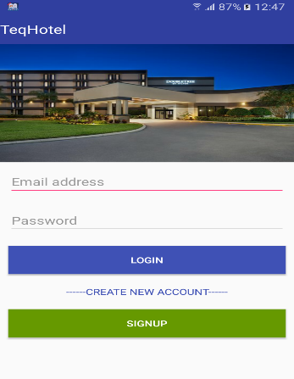

When manager login the system, manager login page has 5 main menus such as guest, staff, room, message, logout.

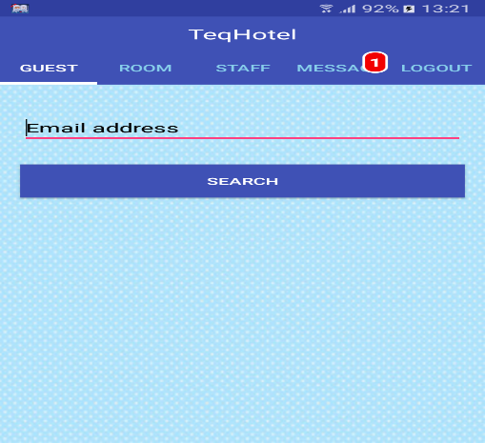

* Guest – View the guest details
* The staff button has 4 options such as add staff, view detail, update detail, remove.
  + Add staff – add new staff details
  + View detail – view the staff details
  + Update detail – update the staff details
  + Remove – remove the staff
* The room button has 2 options such as available room, all room, set room rate
  + Available room – view the available (available on that day) details
  + All room -view all room (rooms in hotel) details
  + Set room rate – change the price of the specific room type
* Message - Show the details of requested rooms and manger can accept/decline every request
* Logout – Go to login page

When guest login the system, guest login page has 5 main menus such as room, cancel, service, message, logout.

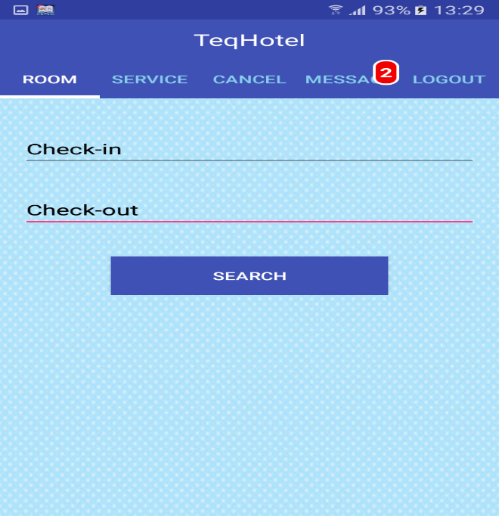

* Room – Show available room for that specific period of time and guest can request to reserve the room
* Cancel – Cancel the room booking (the room that is reserved)
* Service – View all hotel services and request for specific hotel service
* Message – View the response for the room booking (the room is accepted or declined)
* Logout - Go to login page

When Receptionist login the system, receptionist page has 2 main menus such as service and logout.

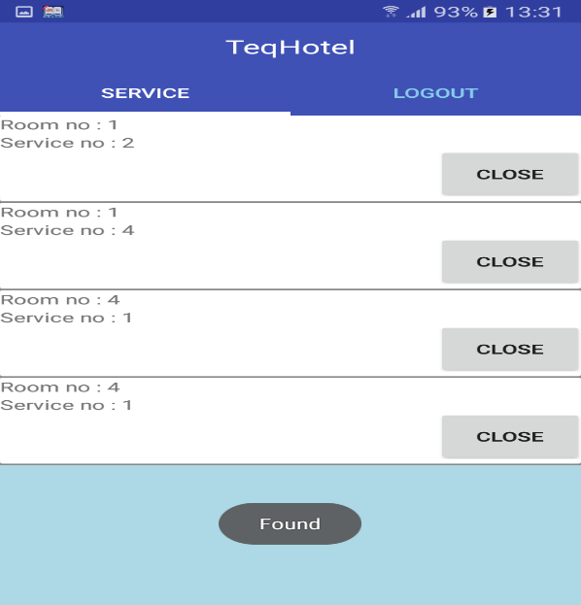

* Service – Show the details of requested hotel services
* Logout – Go to login page